**BRIDESTOWE VILLAGE HALL**

**Pool Hill**

**Bridestowe**

**Okehampton**

**Devon EX20 4EQ**

**01837 861777**

[**www.bridestowe.org.uk**](http://www.bridestowe.org.uk)

Email: **bvh@bridestowe.org.uk**

Situated in a picturesque location just off the A30 near Okehampton with spectacular views over Dartmoor, Bridestowe Village Hall is a perfect venue for wedding receptions, parties, business meetings, exhibitions, community and commercial events.

Since 2012 the venue has proved very popular with the local community providing a home for village events, group meetings, clubs, private events, arts and crafts exhibitions and business training.

Available for hire alongside the spacious 130m2, 200 person capacity Phil Rattenbury Hall we have additionally, the Margaret Moore Suite, a 40 person, multi use room with a bar that can connect to the main hall and a smaller 12 person meeting room. There is a kitchen area that hirers can use, equipped with crockery and utensils for the preparation of refreshments and pre prepared food and we can also provide tables and chairs for your event if required.

All parts of the building are fully accessible and step free with ramped access from the car park. There is also a disabled toilet and baby changing facilities on site.

The rooms and the main hall can be hired individually or you can book the entire building for your exclusive use, whatever is needed to suit your event size and if you are considering us as a venue for your event, please give us a call, we will be happy to show you around before making your booking so you can be sure that Bridestowe Village Hall is right for you.

The fully enclosed, safe, outside space is a lovely feature of the hall and plays host to the annual village Ram Roast along with other activities including group summer camps.

To make a booking please call

01837 861777

Or email

bvh@bridestowe.org

**Phil Rattenbury Hall**

**Margaret Moore Suite**

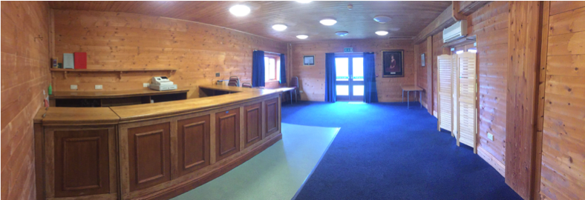

**Kitchen area and small meeting room**

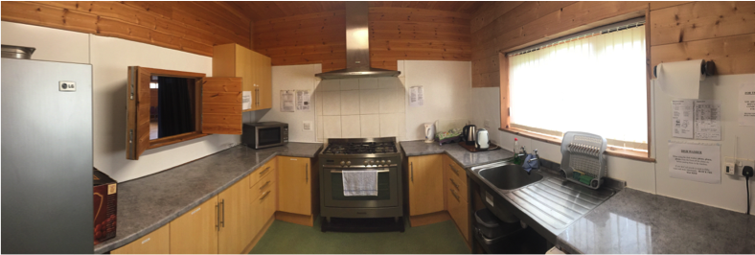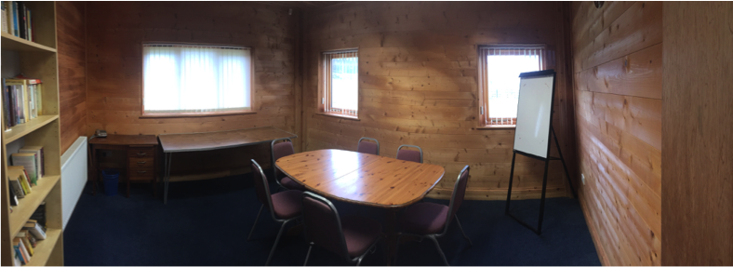

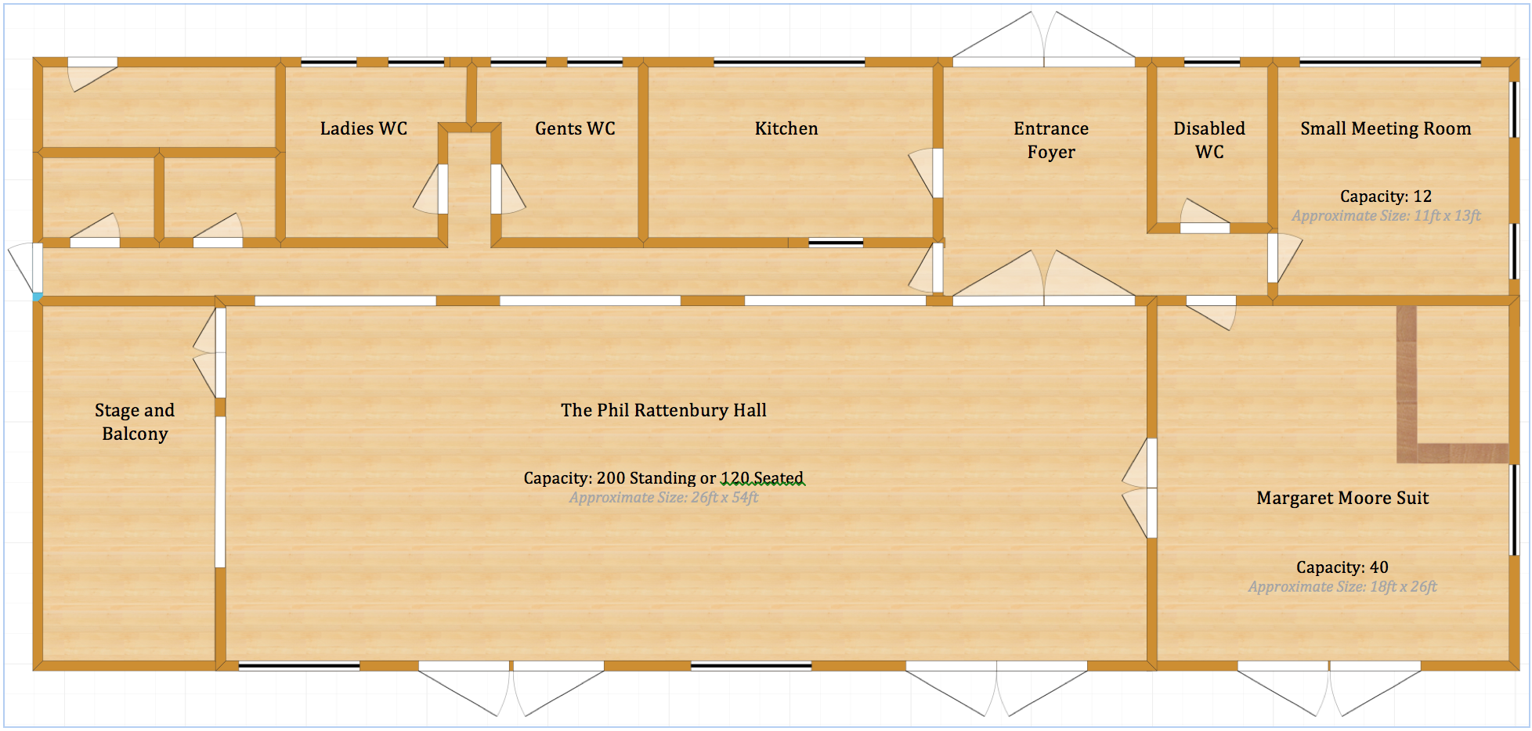

We are located off the A30 on the West Devon Way just before the Bridestowe village turning.

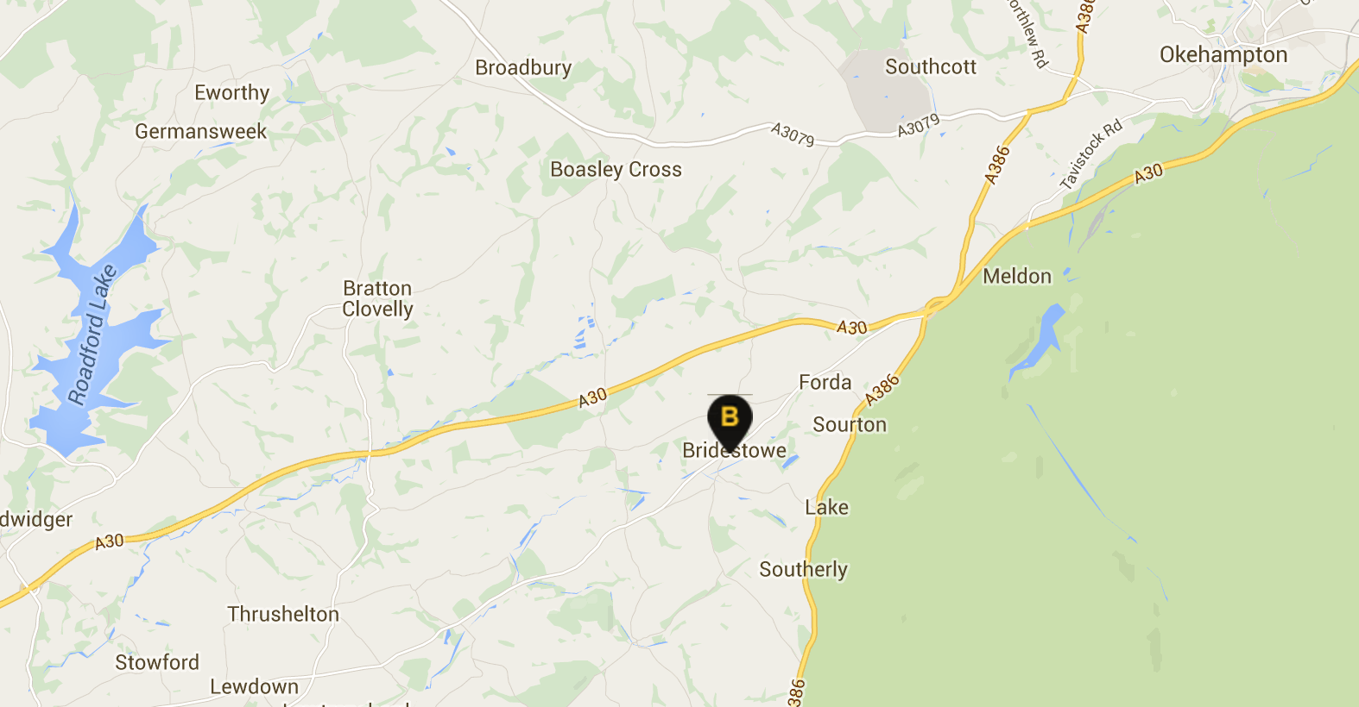

***Bridestowe Village Hall General Terms and Conditions of Hire***

*By submitting a booking form, the Hirer acknowledges and agrees to the following terms and conditions. For the purposes of this agreement Bridestowe Village Hall and its Trustees shall be referred to as “BVH” and the individual or organisation listed on the booking form as ‘the “Hirer” Detailed operational instructions, cleaning expectations, and safety information will be given in a “Guidance for Hirers” document that will be provided at the time of confirmation.*

*1.* ***Booking Process***

* *All bookings must be submitted to the Booking Secretary.*
* *The person named on the booking form will be considered the Hirer. If an organisation is named, the signatory confirms they have the authority to act on behalf of the organisation.*
* *The Hirer must be over 21 years of age and agree to these terms and any additional conditions imposed by BVH.*
* *The hire period is limited to the times agreed on the booking form, and access to the premises outside these times is not permitted without prior approval.*
* *The premises must only be used for lawful purposes, and BVH makes no guarantees about the suitability of the building for any specific purpose.*
* *Local community groups and village organisations have priority over other bookings.*

*2.* ***Hire Charges***

* *A deposit of £100 must be paid within 48 hours of booking confirmation. The balance is due at least 30 days before the event.*
* *The deposit will be retained as a damage deposit and refunded after satisfactory inspection of the premises, provided the Hirer has complied with all terms and conditions.*
* *Failure to abide by these terms and conditions, or any damage to the hall, its grounds, or property, may result in the partial or total loss of the deposit depending on the circumstances. BVH reserves the right to charge for any additional costs incurred, such as cleaning services or repairs, if the hall or grounds are not left in the same condition as they were at the start of the hire.*

*3.* ***Cancellation Policy***

* *The Hirer may cancel the booking with at least 30 days' written notice, in which case all payments, less any expenses incurred by BVH, will be refunded.*
* *Cancellations made with less than 30 days' notice will result in forfeiture of the deposit.*
* *BVH reserves the right to cancel bookings, giving at least 30 days' notice. In such cases, all payments will be refunded, and BVH is not liable for any resulting losses.*

*4.* ***Right of Refusal***

*BVH reserves the right to refuse any booking application without providing a reason.*

*5.* ***Alcohol***

* *Alcohol may be provided free of charge to individuals over the legal drinking age.*
* *The sale of alcohol is prohibited unless the Hirer has obtained permission from BVH and secured the appropriate licence.*
* *No event may be advertised as having alcohol for sale without prior consent from BVH.*

*6.* ***Public Premises Licence***

* *The Hirer must adhere to all conditions attached to the hall's Public Premises Licence, including restrictions on noise and music after midnight.*

*7.* ***Other Licences***

*The Hirer is responsible for obtaining any necessary licences for performances, including Performing Rights Society licences. Copies must be provided to BVH upon request.*

*8.* ***Subletting***

*Subletting any part of the building or grounds is strictly prohibited.*

*9.* ***Advertising for Events***

*All advertising for the Hirer's event must comply with the conditions of hire. This includes posters, flyers, social media promotions, and other forms of media. Non-compliance with these conditions may result in forfeiture of the deposit.*

*10.* ***Breakages and Damage***

*The Hirer is responsible for any damage to the hall, its equipment, or grounds during the hire period and must cover repair or replacement costs.  
Failure to report or rectify any damage may result in additional charges beyond the deposit if the cost of repair or replacement exceeds the deposit amount.*

*11.* ***Liability and Indemnity***

*BVH accepts no liability for loss, damage, or injury to persons or property during the hire period. The Hirer must indemnify BVH against any claims arising from the event, including accidents, negligence, or damage caused by the event's attendees.*

*12.* ***Conduct and Good Order***

* *The Hirer is responsible for maintaining good order during the event, ensuring that attendees behave properly on arrival, during, and when leaving the premises.*
* *BVH reserves the right to report any criminal activity to the police.*
* *Any serious breaches may result in forfeiture of the damage deposit.*
* *The Hirer must also ensure that attendees do not trespass onto neighbouring properties or fields by climbing over fences or gates.*
* *Any incident involving disorder, injury, or harm whether the emergency services are involved or not must be reported to the Trustees of BVH as soon as possible following the incident.*

*13.* ***Condition on Vacation***

*The premises must be left clean and in good order. All rubbish must be removed by the Hirer. Any property left on the premises will incur a storage fee and must be removed within 15 minutes of the hire's end unless prior arrangements have been made.  
Failure to leave the premises in a satisfactory condition may result in the loss of the deposit, and BVH reserves the right to charge for additional costs, such as hiring professional cleaners or gardeners if the building or grounds are damaged or left in an unsuitable condition (e.g., excessive dirt, damage to grass or garden areas).*

*14.* ***Signage and Decorations***

*No fixtures or signs may be attached to the building without BVH’s consent. The Hirer must remove any decorations or signage at the end of the hire.*

*15.* ***Fire Safety and Visitor Safety***

* *The Hirer is responsible for ensuring that all attendees are informed about fire safety procedures, including the location of fire exits.*
* *Fire exits must be kept clear, and fire alarms and extinguishers must not be tampered with.*
* *The use of any open flames on the premises, including but not limited to fire pits, disposable barbecues, and candles, is strictly prohibited.*
* *Smoke machines, pyrotechnics, fireworks, flammable liquids, and Chinese lanterns are also strictly prohibited within the building or in the grounds.  
  Failure to comply with fire safety rules may result in immediate cancellation of the hire, loss of deposit, and additional charges if damages or risks are incurred.*

*16.* ***Health & Safety***

*Any accidents or dangerous occurrences during the hire must be reported to BVH and recorded in the accident book, which is located in the foyer.*

*17.* ***Safeguarding***

*If the event involves children or vulnerable adults, the Hirer must ensure compliance with relevant safeguarding legislation and provide BVH with any required documentation, such as safeguarding policies or DBS checks.*

*18.* ***Smoking***

*Smoking, including the use of e-cigarettes and vapes, is prohibited in the hall and grounds, except in designated areas such as the car park.*

*19.* ***Electrical Equipment***

*No additional electrical equipment may be installed without BVH’s prior consent.*

*20.* ***Capacity***

* *The maximum capacity for the Main Hall is 200 people. The Margaret Moore Suite can hold up to 40 people.*
* *Under no circumstances should the total number of attendees exceed 240.*

*21.* ***Parking***

*Vehicles must be parked in the designated parking area and not on grass verges. BVH does not accept responsibility for any damage to vehicles parked on the premises.*

*22.* ***Environmental Responsibility***

*BVH is committed to reducing its environmental impact and protecting local wildlife and farm animals. As part of this commitment:*

* *The release of foil helium or similar balloons, non-degradable confetti, or any other environmentally harmful materials is prohibited on the premises and in the surrounding grounds.*
* *Hirers are encouraged to minimise waste, use eco-friendly materials, and ensure that the hall and grounds are left in a clean and sustainable condition.*
* *Any breach of these environmental rules could result in the loss of the deposit or further charges if additional clean-up or repairs are necessary.*